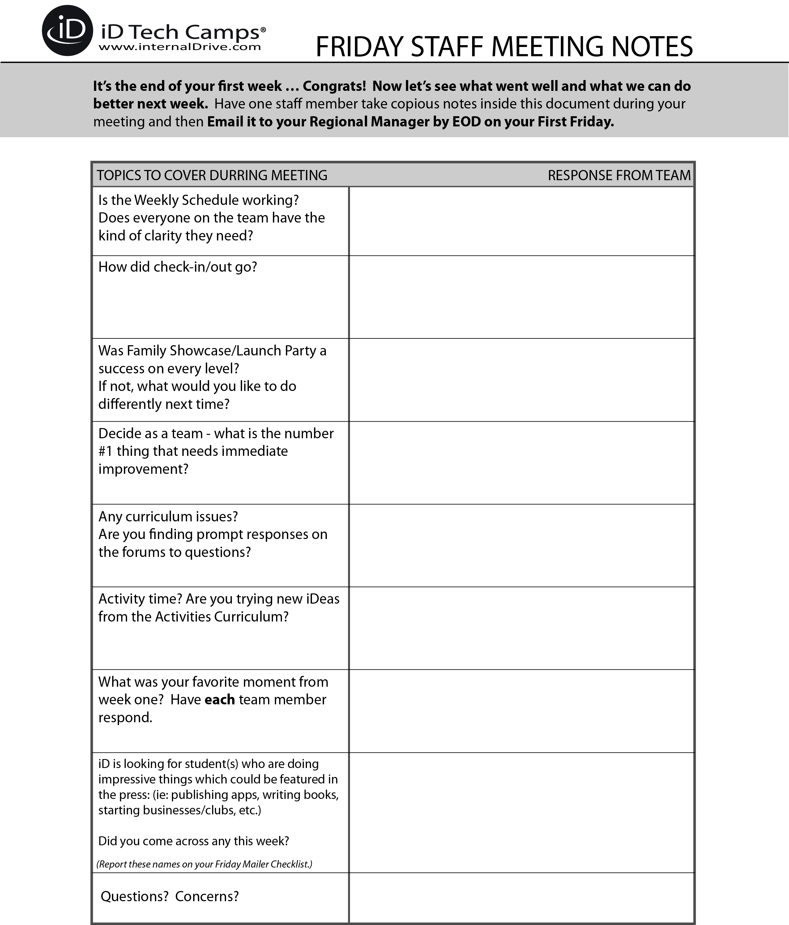

Notes:

Notes:

Notes:

Notes:

Notes:

Notes:

Notes:

Notes:

Notes: